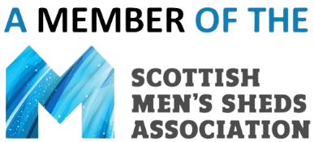

(Insert Shed name)
Alcohol and Drugs Policy

Policy statement:
(Insert Shed name) is a welcoming and inclusive alcohol-free and drugs-free environment. The Shed is a safe space for everyone that attends including people who have or have had issues with alcohol or drugs.

Reasons for the policy:
Men's Sheds exist for the health and wellbeing of their members. Many people have issues with alcohol or drugs, whether or not they choose to share this with others. This Men’s Shed wishes to safeguard all of its members and visitors.

The policy in detail:
- In line with the worldwide Men's Sheds model, this Men’s Shed does not permit members or visitors to consume or make alcohol or drugs available on the Shed premises. Men’s Sheds provide a culture of socialising in an alcohol and drug free environment to improve health and wellbeing.
- It is acknowledged that this Men’s Shed may wish to host members’ events on Shed premises such as Christmas lunches, Hogmanay celebrations etc. - outside of normal Shed opening hours and may wish to introduce alcohol. The Shed will be mindful that this may impact on some members’ attendance and feelings of inclusion and members should be consulted before arrangements are put in place.
- This Men's Shed will not pay for or subsidise alcoholic drinks at any events, even if food and other consumables are subsidised by the Shed.
- No member or visitor of this Men's Shed under the influence of alcohol or drugs are permitted to be on the premises.

Breaches of the policy:
If a member or visitor is suspected of being under the influence of alcohol or drugs, the individual aware of this should notify a Shed Supervisor or a Trustee immediately. Safeguarding is everyone’s responsibility.

It is at the discretion of this Men’s Shed’s Trustees to investigate and determine any actions to be taken in the event of any breaches of this policy.

