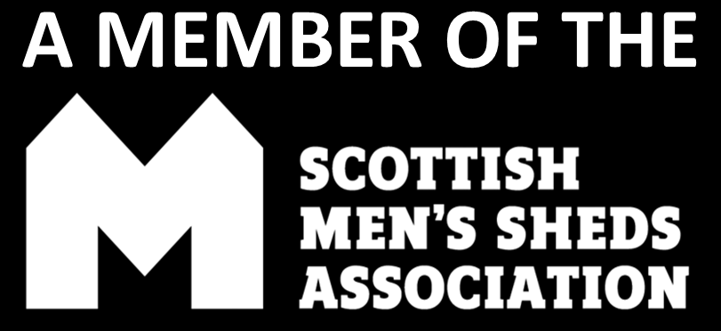

*INSERT SHED NAME*

EQUALITY, DIVERSITY AND INCLUSION POLICY
SMSA Template Version: March 2024

Men’s Shed Equality, Diversity and Inclusion Policy

Introduction

A Men’s Shed is a community-based, non-profit, non-commercial organisation accessible to all men, providing a safe, friendly and healthy environment.

A Men’s Shed aims to:

- provide a supportive single sex environment for men to socialise together, with the opportunity to voluntarily work on purposeful projects learning and sharing skills; and
- promote the mental, physical, emotional and economic wellbeing of people in our community.

Legislative Framework
The main piece of legislation which covers equal opportunities and discrimination is the Equality Act 2010. The Equality Act 2010 sets out nine protected characteristics under which protection and redress are afforded. These are:

- Age
- Disability
- Gender reassignment
- Marriage and civil partnership
- Pregnancy and maternity
- Race
- Religion or belief
- Sex
- Sexual orientation

Glossary of Terms

Direct Discrimination
Treating any individual less favourably than others on the grounds of a protected characteristic.

Indirect Discrimination
Imposing on an individual, requirements, that are in effect more onerous than they are on others. This would include applying a condition which makes it more difficult for members of a group to comply than others not of that group.

Discrimination by association
Where a person is discriminated because they are associated with another person who possesses a protected characteristic.

Discrimination by perception
Where a person is discriminated against because they are perceived as belonging to a group, irrespective of whether this is correct.

Harassment
Where a person is subjected to unwanted conduct related to a relevant protected characteristic which has the purpose or effect of violating their dignity, or creating an intimidating, hostile, degrading, humiliating or offensive environment for them.

Victimisation
Where a person is treated unfairly because they have made a complaint about discrimination or have given evidence in a discrimination case.

Unconscious bias
Where social stereotypes about certain groups of people unconsciously affect decisions, behaviours and thoughts. It is important that all members try to recognise these biases and actively challenge them.

Aims of the Equality and Diversity Policy

- The Men’s Shed recognises that in our society power is not held equally and that groups and individuals have been and continue to be discriminated against on the grounds of protected characteristics.
- The Men’s Shed also recognises that where direct or indirect discrimination, harassment and victimisation, including by association or perception, occurs within the Men’s Shed, it is both morally and legally unacceptable.
- The Men’s Shed aim is to provide an environment free from bullying and harassment, intimidation, or discrimination in any form which may affect the dignity of the individual.

To achieve this, the Men’s Shed will:

- Act in the best interests of the Shed and not pursue personal agendas – think collectively through a democratic process, not individually.
- Treat people with dignity and respect regardless of their protected characteristic.
- Provide a safe physical environment.
- Provide a safe and supportive social environment.
- Be able to guide members to other services or agencies when appropriate or requested.
- Respect the rights of members.
- Respect the confidentiality and privacy of members.

The environment and code of conduct in the Men’s Shed

- The Men’s Shed will not tolerate abuse, bullying, violence, anti-social behaviour or infringements of the rights of others. Persons indulging in this type of behaviour will be asked to leave the Men’s Shed.
- Members are expected to conduct themselves in a courteous manner towards Supervisors, Committee/Board members, key stakeholders and other users of the Men’s Shed. This includes being considerate of other people’s need for space, tools, materials and equipment.
- In the event of conflict, the Men’s Shed has in place formal policies and procedures that outline the courses of action to follow (see the Shed’s Constitution)
- The Men’s Shed will act to ensure that their facilities, activities and events are open, accessible and welcoming to everybody entitled to become a member.

- The Men’s Shed will ensure all those who engage with them are treated fairly and are not subjected to unfair or unlawful discrimination.
- The Men’s Shed will use local training opportunities if available to help the Shed Committee/Board and members better understand how discrimination occurs and how to prevent it.
- All members of the Men’s Shed will have the Equality and Diversity Policy explained to them and will undertake to comply with and implement this policy.
- Members who have experienced discrimination can make complaints to the Equalities and Diversity Co-ordinator who could be a designated person, Shed Supervisor or trustee. If the Equalities and Diversity Co-ordinator is unable to resolve the complaint, then refer it to the Shed Committee/Board.

Dealing with Complaints

- The Shed Committee/Board will take complaints of discrimination and harassment very seriously.
- The Shed Committee/Board will investigate complaints thoroughly and provide opportunities for the person making the complaint to speak in a safe environment about their experience.
- If the complaint is against an individual, the Shed Committee/Board will also hear their point of view.
- The Shed Committee/Board will then decide the action to take based on the principle of ensuring the continued inclusion and safety of any member who has experienced discrimination, harassment or victimisation.
- Any decision to terminate someone’s membership will be made in line with the rules set out in the Constitution.

Name and contact details of designated Equality, Diversity and Inclusion Co-ordinator:

Name:
Telephone:
Email:

Review

This policy will be reviewed every two years, or if Scottish legislation changes, by the Shed committee or the Shed Board of trustees.

Name (PRINT):
Position:
Signature
Date:
Witness Name (PRINT):
Witness Signature:
Date:

Document version control

Version number | Change or update | Author or owner | Date | Any comments
1.0 | First version

