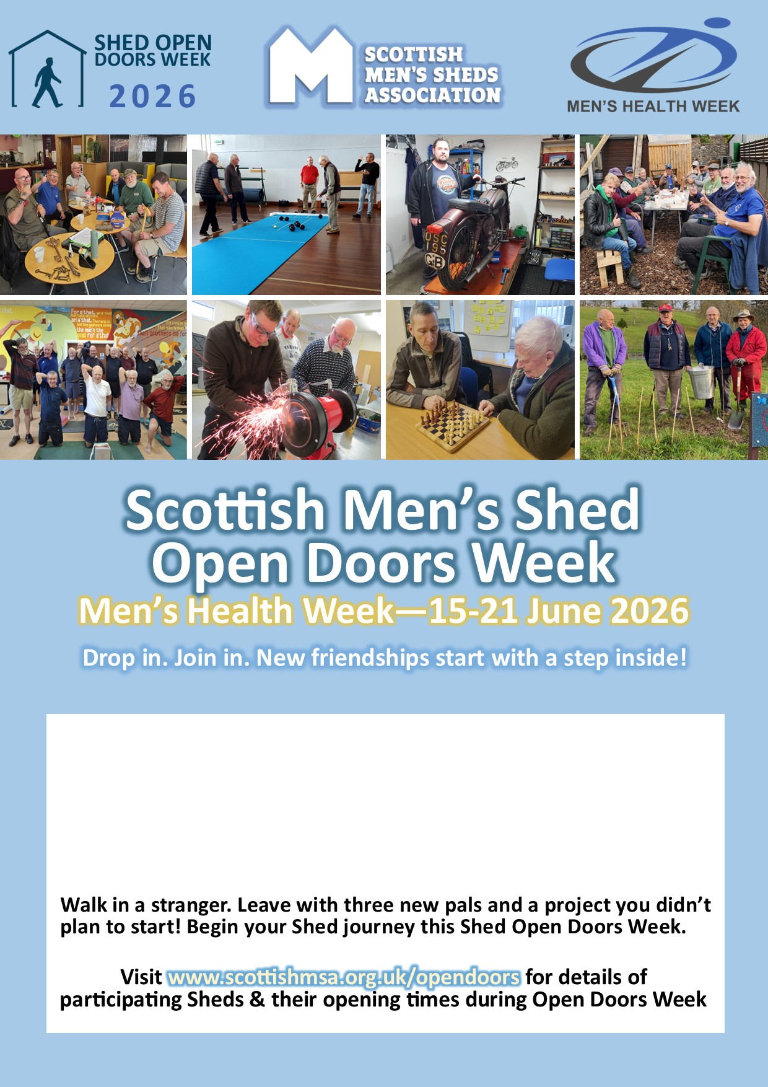
Name of Men’s Shed: | XXX Men’s Shed
Location/Address: | *Highlight any specific directions or access issues here
Opening time(s) during Open Doors week: | Days and times e.g. the full week, one day?
Contact: | Phone number or email for a Shed contact

