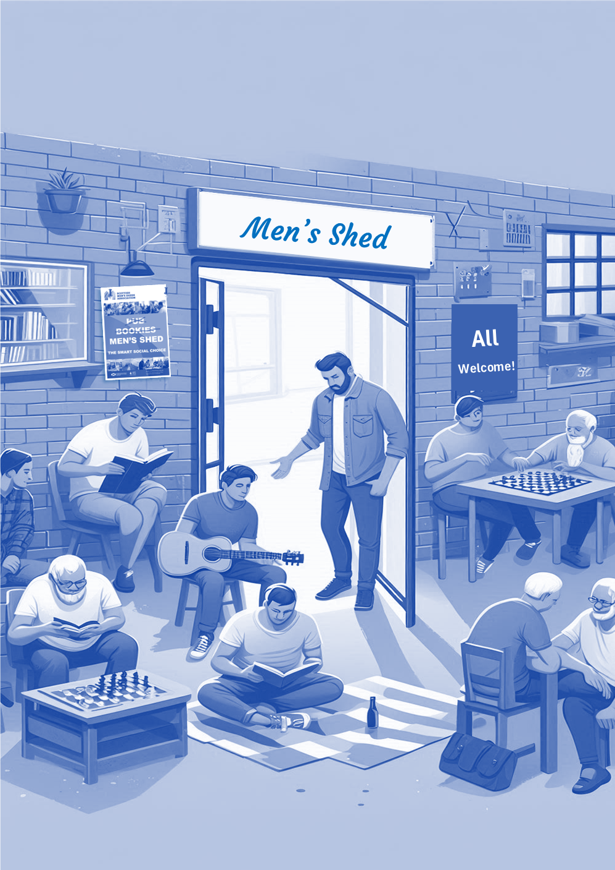

**\*Insert Shed name*   
Open Doors Day**

**On International Men’s Day**

**TuTuesday 19th November 2024**

**From Xam to pm**

OPEN DOORS

|  |
| --- |
|  |

**#shedopendoors #bringalongafriend #scottishshedder  
www.scottishmsa.org.uk/doorsopen**